# Learning Outcome

# After completing this module, the student should be able to understand how to install Angular Js.

To meet the learning outcome, a student has to complete the following activities

1. Installation of node js and angular js (1.5 Hrs)
2. Creating a Angular Js Application (3 Hrs)

# Activity 1

## Aim: Installing Angular Js.

**Learning outcome:** Able to understand basic how to install angular js.

**Duration:** 1.5 hour

**List of Hardware/Software requirements:**

1. Operating system - Windows 10/11 or Linux
2. Command prompt
3. Internet connectivity

**Code/Program/Procedure (with comments):**

**Step 1: Install Node.js**

Angular bases its build environments on Node.js, and many of its features depend on NPM packages. Conveniently, the Node Package Manager (NPM) client is part of the default Node.js package.

**To install Node.js:**

1. Visit the [official Node.js page](https://nodejs.org/en/download/) and download the latest Node.js **Windows Installer**.

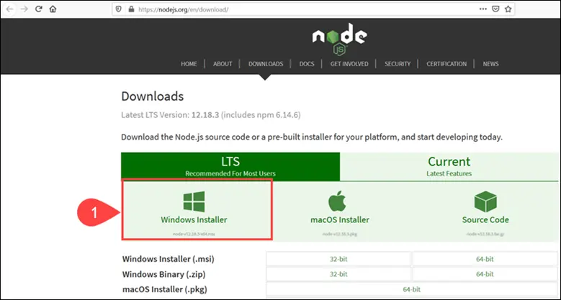

1. Access the download location and double-click the Windows Installer Package.
2. Select **Next** on the initial Node.js Setup Wizard screen.

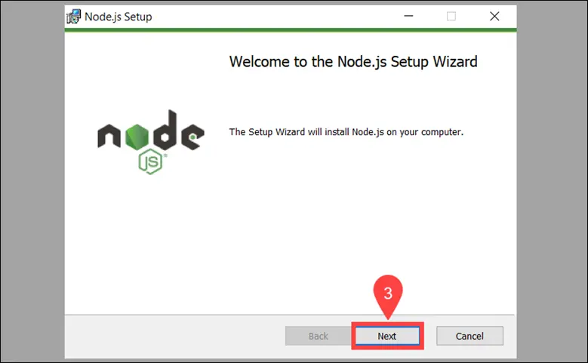

1. **Accept** the *License Agreement* and click **Next.**

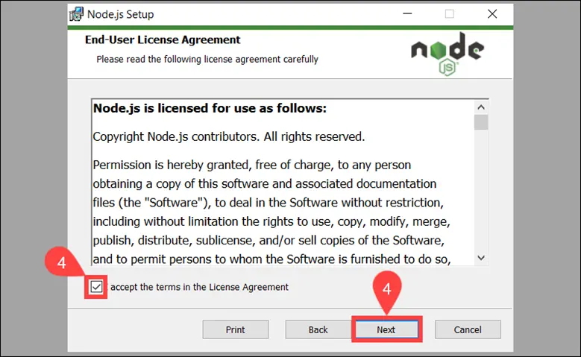

1. Define the **destination folder** for the installation and select **Next.**

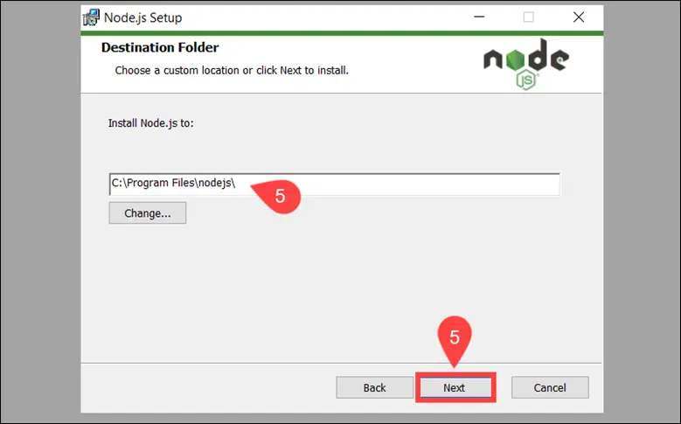

1. You can customize how to install available features. Make sure that the **npm package manager** is part of the installation bundle. Click **Next** to proceed.

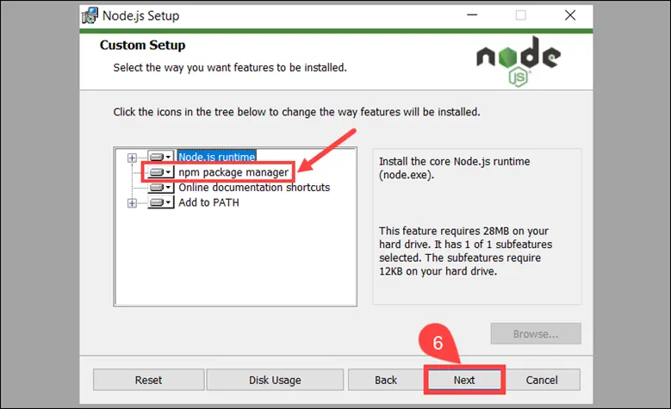

1. Check the box if you would like to install tools for compiling native modules automatically. They are not mandatory and require an additional 3 GB of space. Select **Next** to continue.

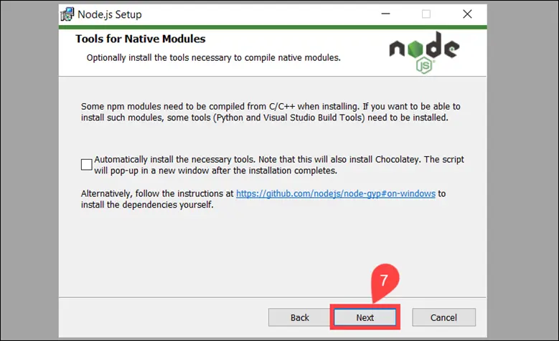

1. Click **Install** to start the installation process.

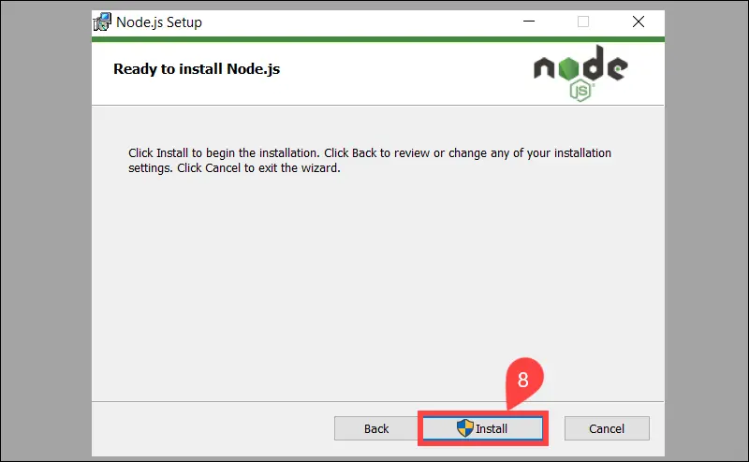

1. Once the installation is complete, select **Finish** to exit the Setup Wizard.

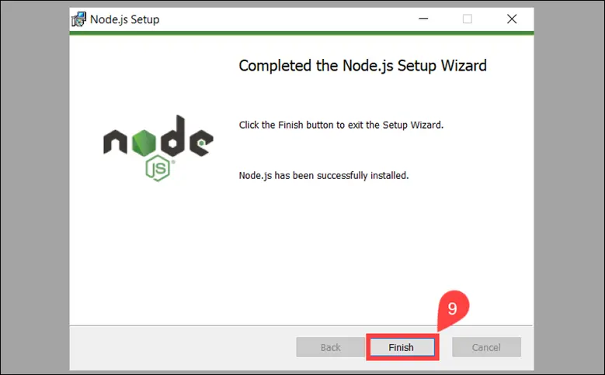

1. Access the Windows Command Prompt (or PowerShell) and check the Node.js version:

node -v

The system confirms that Node.js **v14.17.0** is installed.

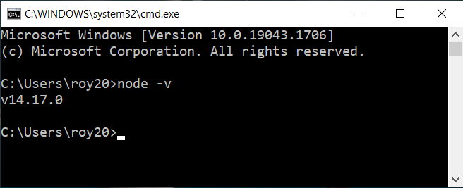

1. To verify the NPM version, use the following command:

**npm -v**

The output shows you have installed NPM version 8.3.2.

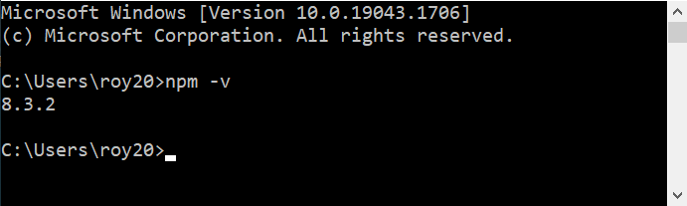

**Step 2: Install Angular CLI**

The Angular command-line interface (CLI) tool allows you to initialize, develop, and manage your Angular applications. You can use the NPM package manager to install the Angular CLI.

1. Access the Windows Command Prompt and enter the following command:

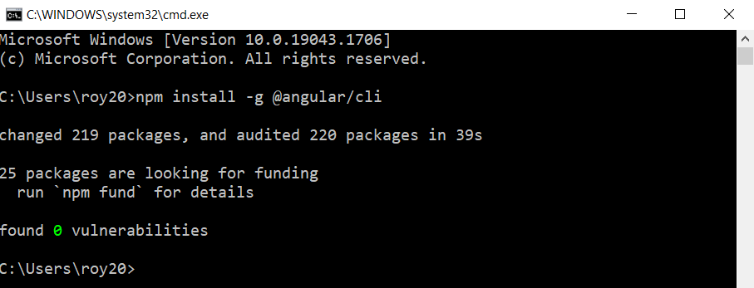

2. Once all packages have been added, verify the installed version:

**ng version**

The Angular CLI version is**14.0.1**

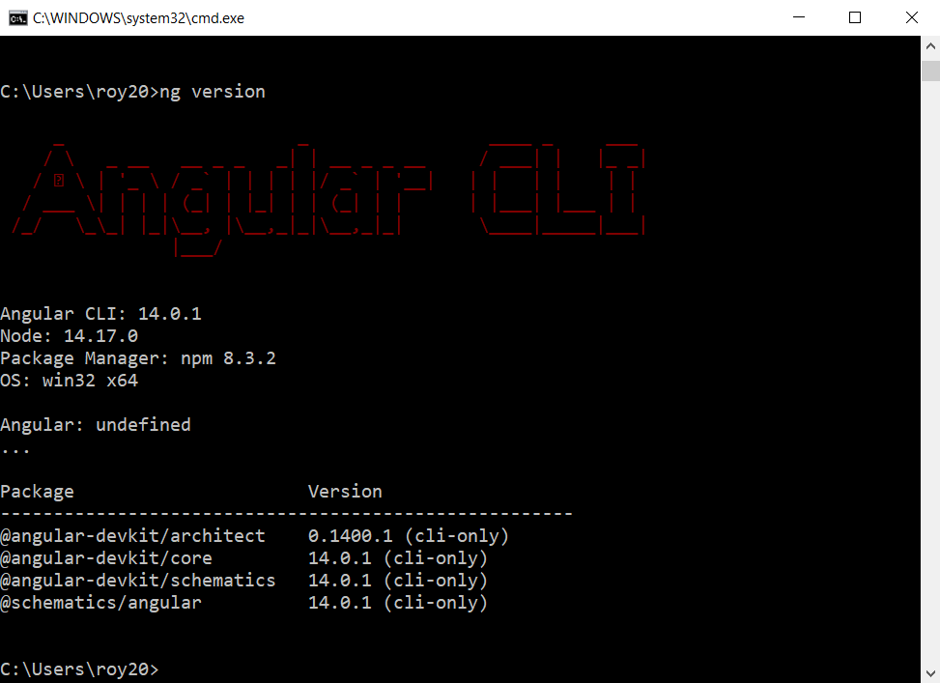

**Step 3: Create Angular Project**

1. Use the Angular CLI to start a new Angular project. It this example, the name of the project is kitchen-sink. You are free to use the name of your choice for your project name. Type the following command in your Windows Command Prompt:

**ng new myfirst-project**

Before proceeding, you can customize the application. Define if you would like to use Angular routing and choose a stylesheet format. These settings can be edited at a later point.

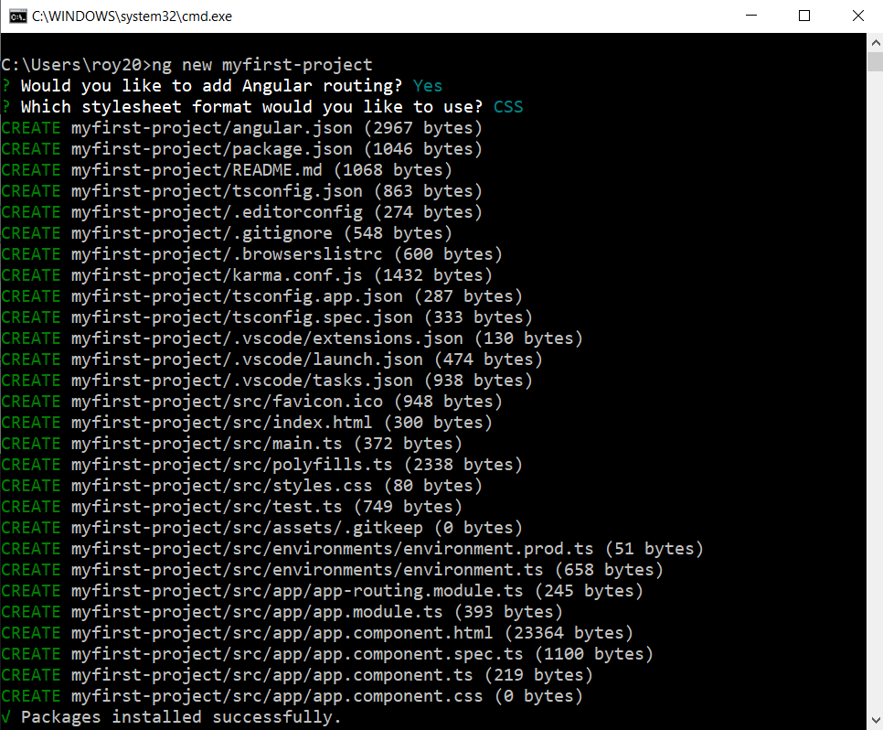

The system takes a few moments to create the project. Once it finishes, you see the “Packages installed successfully” message.

2. Access your project’s root folder (myfirst-project in this example) from the Windows Command Prompt and enter the following command:

**ng serve**

The system proceeds to generate the environment for your Angular application.

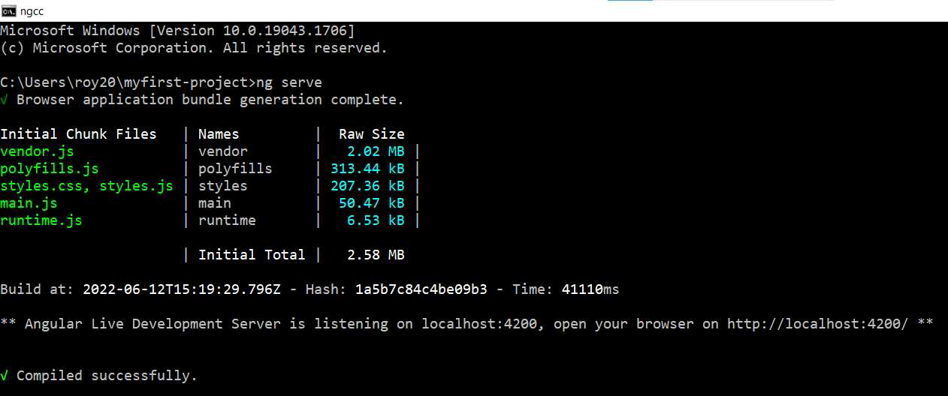

Keep the Windows Command Prompt running. You can continue using the terminal, and the changes you make will be reflected in the application within your browser.

3. Use any browser to access your Angular local development server on localhost:4200:

<http://localhost:4200/>

You can now start creating new Angular components.

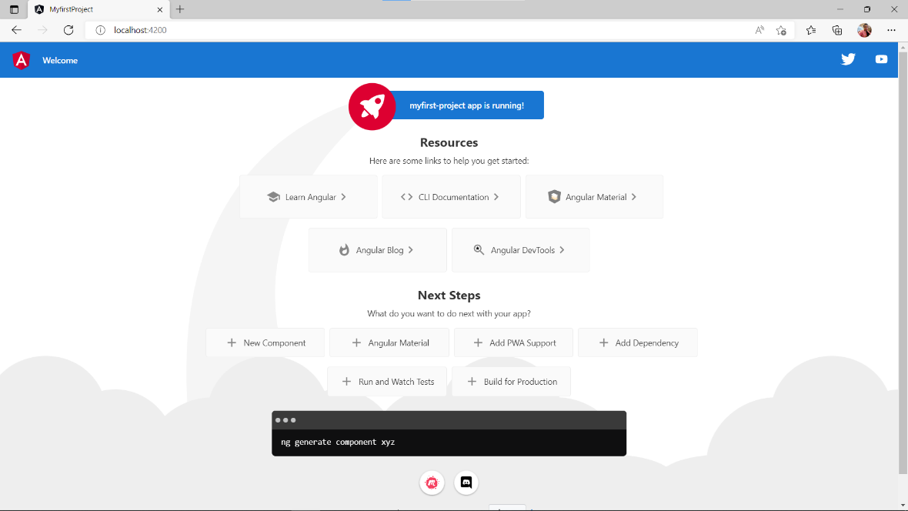

# Activity 2

## Aim: Create an Angular application which add, multiply, divide the two input numbers from textbox.

**Learning outcome:** Able to understand how to create an angular application.

**Duration:** 3 hour

**List of Hardware/Software requirements:**

1. Operating system - Windows 10/11 or Linux
2. Command prompt
3. Internet connectivity, Browser (chrome or edge)
4. Text Editor – Visual Studio Code / Notepad

**Code/Program/Procedure (with comments):**

1. Open Visual Studio.
2. Let's create a simple AngularJS web application step by step and understand the basic building blocks of AngularJS.
3. First, create an HTML document with <head> and <body> elements, as show below.

Example: HTML Template

<!DOCTYPE html>

<html>

<head>

</head>

<body>

</html>

1. Include angular.js file in the head section (you have learned how to download angular library in the previous activity). You can take a reference from the CDN also. Example: Include AngularJS Library.

<!DOCTYPE html>

<html>

<head>

<title>AngularApp</title>

<script src= " https://cdnjs.cloudflare.com/ajax/libs/angular.js/1.8.3/angular.js "></script>

</head>

<body>

</body>

</html>

1. Here, we will be creating a simple calculator application which will add, subtract, multiply, divide two numbers and display the result.

<!Doctype html>

<html lang="en">

<head>

<meta charset="utf-8">

<title>AngularApp</title>

<base href="/">

<meta name="viewport" content="width=device-width, initial-scale=1">

<link rel="icon" type="image/x-icon" href="favicon.ico">

<script src= "https://cdnjs.cloudflare.com/ajax/libs/angular.js/1.8.3/angular.js"></script>

</head>

<body ng-app>

<h1>First AngularJS Application</h1>

Enter Numbers to Add:

<input type="number" ng-model="Num1" /> + <input type="number" ng-model="Num2" /> = <span>{{Num1 + Num2}}</span> <br><br>

Enter Numbers to Subtract:

<input type="number" ng-model="Num3" /> - <input type="number" ng-model="Num4" /> = <span>{{Num3 - Num4}}</span> <br><br>

Enter Numbers to Multiply:

<input type="number" ng-model="Num5" /> x <input type="number" ng-model="Num6" /> = <span>{{Num5 * Num6}}</span> <br><br>

Enter Numbers to Divide:

<input type="number" ng-model="Num7" /> / <input type="number" ng-model="Num8" /> = <span>{{Num7 / Num8}}</span>

</body>

</html>

The above example is looks like HTML code with some strange attributes and braces such as ng-app, ng-model, and {{ }}. These built-in attributes in AngularJS are called **directives**.

The expressions are written inside the ***{{ expression }}***.

***ng-model*** directive helps to bind the value in html control. the above solution we use "Num1" it will contain the first input value."Num2" contain the second input value.

***ng-app*** directive defines the angular js application.

1. Save as index.html

**Output/Results snippet:**

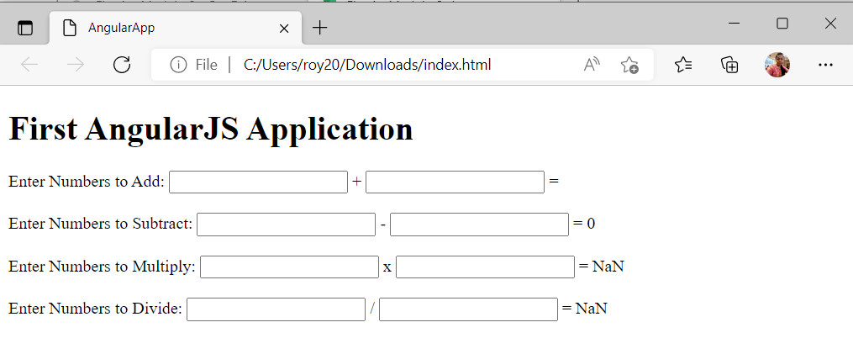

User will enter two numbers in two separate textboxes and the result will be displayed immediately, as shown below.

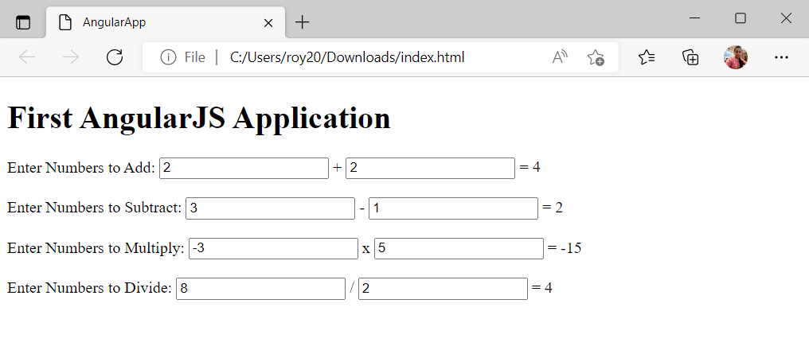

**References:**

* <https://dzone.com/articles/multiplication-of-two-numbers-using-angular-js>